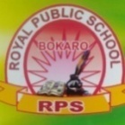**ROYAL PUBLIC SCHOOL (SEC-IV)**

**Class-VII / Holiday homework/Assignment (2020-21)**

**Subject: - G.K**

1. **Fill up the following page no**.-

16,17,18,19,20,21,24,25,26,27

1. **Remember this chapter**.
2. **12**- The Indian parliament
3. **14**- Famous Indian beaches
4. **16**-Famous painting
5. **17-**National symbols
6. **18-** The united nations
7. **19-**Parliaments of different countries