# FINAL EXAMINATION (2024-2025)

**LKG**

**General Awareness**

# **Total Time: 3 hours Total Marks: 50**

General Instructions.

• All questions are compulsory.

• Marks of each question are indicated against it.

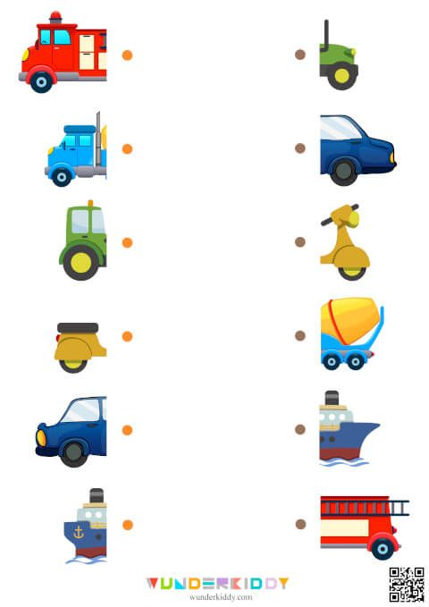A. Match the front and the back half of each of the vehicle (6x1=6)

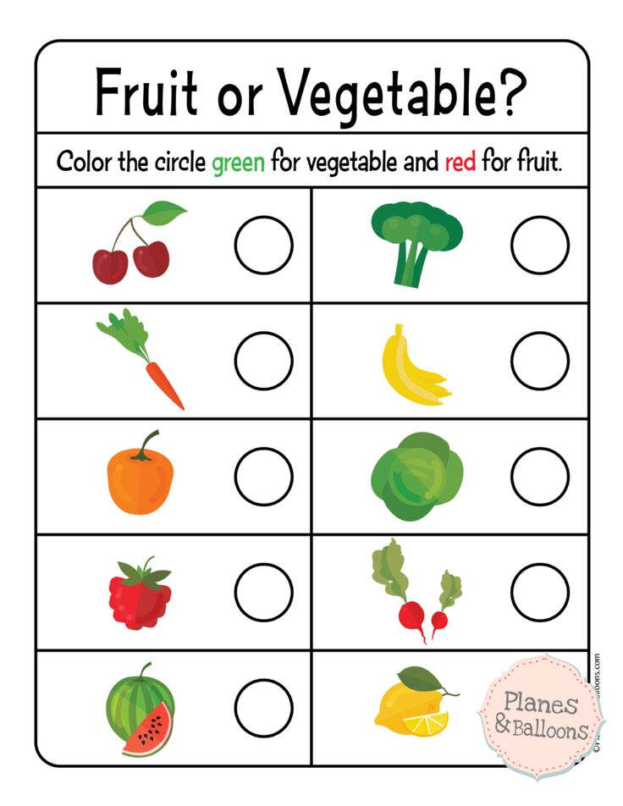B. Color the circle green for vegetable and red for fruit (8x1=8)

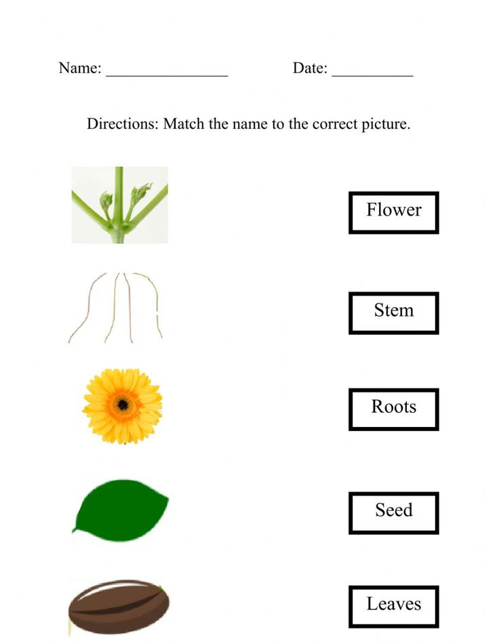C. Match the name with the correct picture (5x1=5)

D.Circle the three Water Animal (4x1=4)

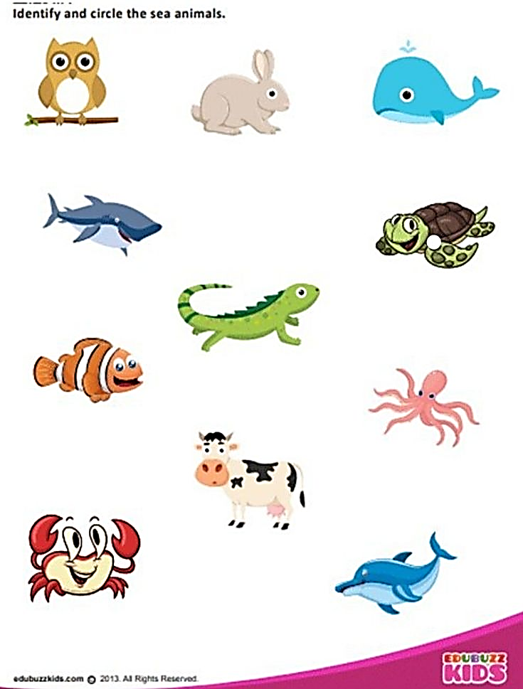

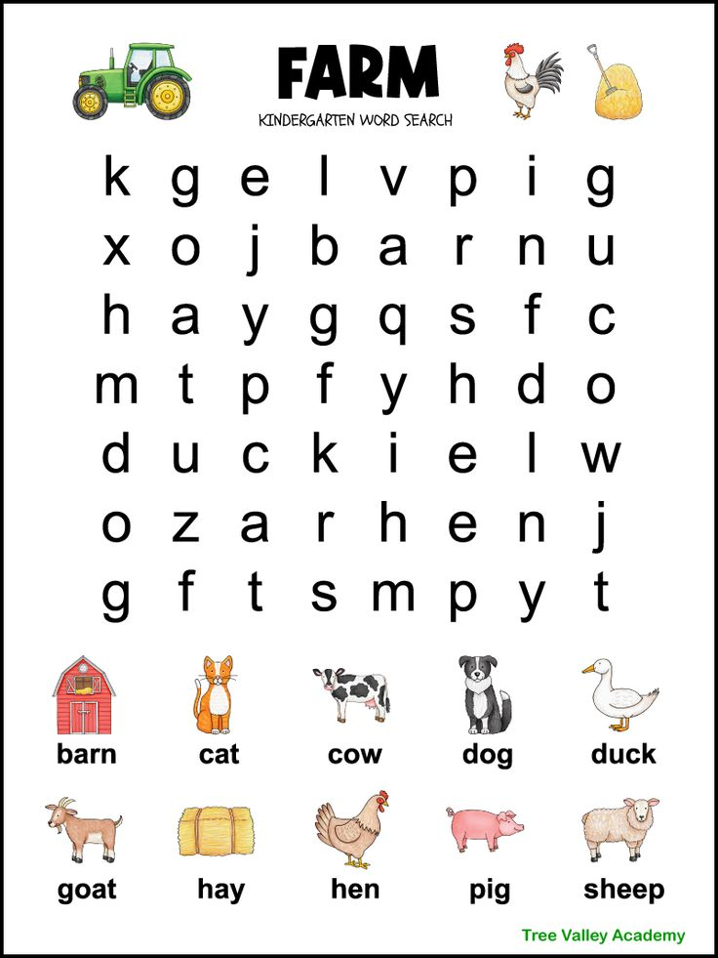E. Find below mentioned word and circle the spellings (10)

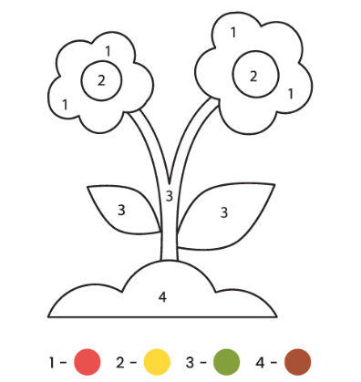F. Color the picture according to the number key at bottom (6)

G. Circle the pictures that use Air (2)

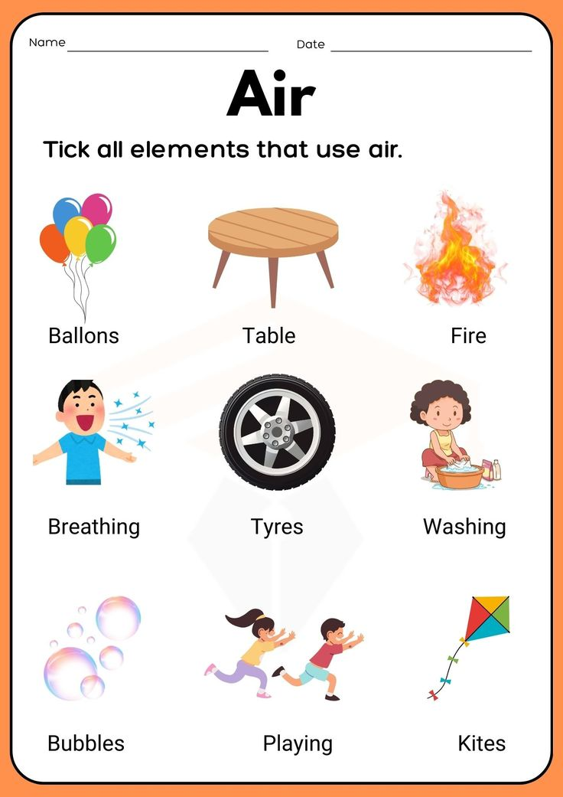

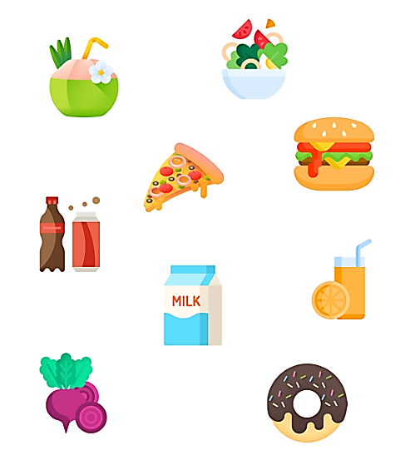H. Circle healthy food (5)

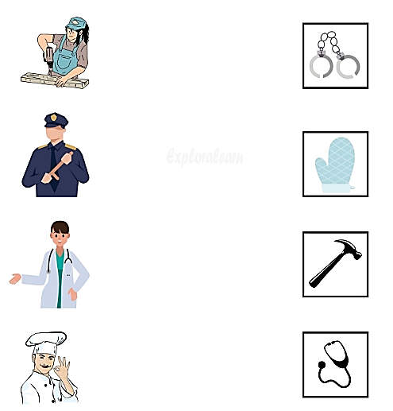I. Match the people with the things that belong to them (4x1=4)